

Winter Semester 2022

CSE250 Database Management System

Project Title:

E - Commerce Management System

**Group Details**

| **Name** | **Enrollment No.** |
| --- | --- |
| Tirth Patel | AU2040020 |
| Rushali Moteria | AU2040210 |
| Akshil Thumar | AU2040258 |
| Ushmay Patel | AU2040253 |

### **Project Description:**

The project is on an **E-commerce management system** coded in Postgres and Nodejs. With the increase in demand for online shopping there is a need to manage and store the huge e-commerce data that is generated everyday. The project develops a system that keeps track of information about different products, its categories, information about customers and shippers. It organizes the data into different interrelated tables which make it easy to store the data without redundancy and access it based on the requirement.

**Requirement Analysis:**

There are major two role in the system:

1. Admin user: The admin will have access to the details of every product, can add products and edit all details. Admin can also access the details of all customers.
2. Customer user: A customer can sign up by entering his details and then will be able to search products, can see the product details, add products to his/her cart and order it.

**Entities:**

The data has been stored in the following entities:

1. Admin
2. User
3. Customer
4. Address
5. category
6. Product
7. Cart
8. Order
9. Payment
10. Shipper
11. Canceled order

**Relationships:**

user 1 : M Address

Customer 1 : 1 Cart

Category 1 : M Product

Product M : M Cart

Cart 1 : M Order

Order 1:1 Payment

Shipper 1:M Order

**Normalization of Tables:**

While creating the database, we have taken in consideration the normalization of tables.

* The attribute of the phone number is multivalued so it has been divided into two different columns.
* A customer can have multiple addresses (multivalued attribute) to which the order can be shipped, so a separate table has been created which stores different addresses of a particular customer by referencing the user id of users table.
* Product and Cart have many to many relation which has been converted to one to many by introducing a bridge entity (Cart product)

**Functionalities:**

**Basic functionalities:**

1. **Managing products:** Admin can add and delete products and can also manage its quantity, price etc.
2. **Accessing customer details:** The admin can view the details of customers including the cart details and the order details
3. **Viewing products:** the customers can view the products based on a particular category or price.
4. **Adding Products to cart**: Customers can add products to cart by adding it as a cart product. Two different entities, cart product and cart, are created. Customers can add or add or delete products from the cart product table, whereas the cart table shows the total amount and quantity of a particular cart.
5. **Placing an order:** Customers can place an order followed by the payment of the same.
6. **Payment:** Customers can pay the amount of products during checkout through different modes of payment like cash on delivery, online payment via credit card or debit card.
7. **Order cancellation:** customers can cancel their order by providing order id.

**Other functionalities:**

1. The admin can search the number of orders that have been canceled.
2. The admin can view the orders placed between two dates.
3. The admin can view the number of products at sale of a particular brand.
4. Customers can view the number of products of a particular category.
5. Update customer details such as phone number and email id (customer name can not be changed)

**System Requirements and Implemented Functions**:

**Backend:**

We have created a backend database in Postgres.

**Frontend:**

We have connected the backend database with the frontend using React(Node JS).

### **B. ER Diagram**

( The following ER Diagram has been made in Lucid Chart)

Link: <https://lucid.app/lucidchart/df779538-a122-4efc-99d6-5cc66738a599/edit?beaconFlowId=9D3FB2B755AAD81B&invitationId=inv_310cd7d8-cf55-4417-9cb7-f51d18b64afb&page=0_0#>

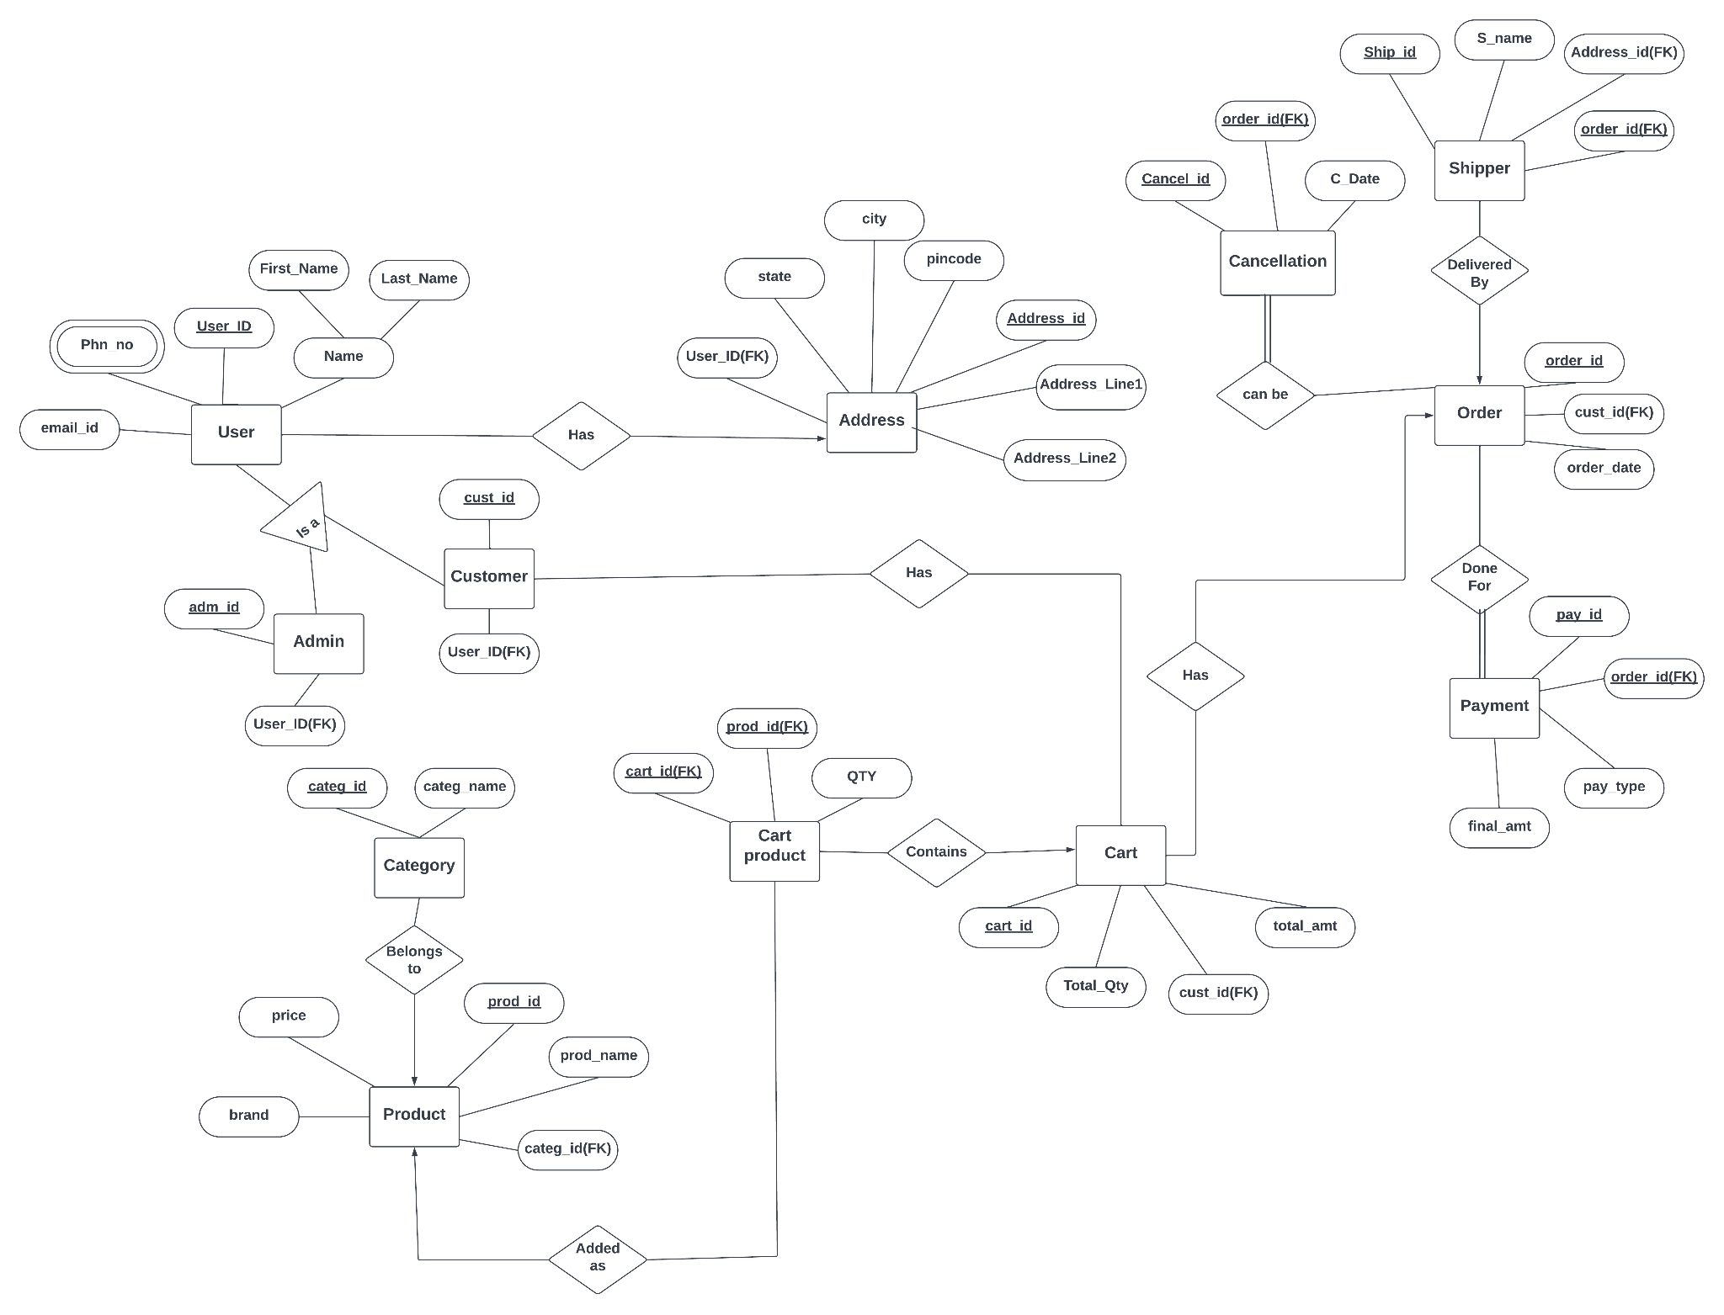

### **C. Table Design**

<https://drive.google.com/file/d/1Tlv449XPx7PA-FolKQDDoFST16Kn5M6-/view?usp=sharing>

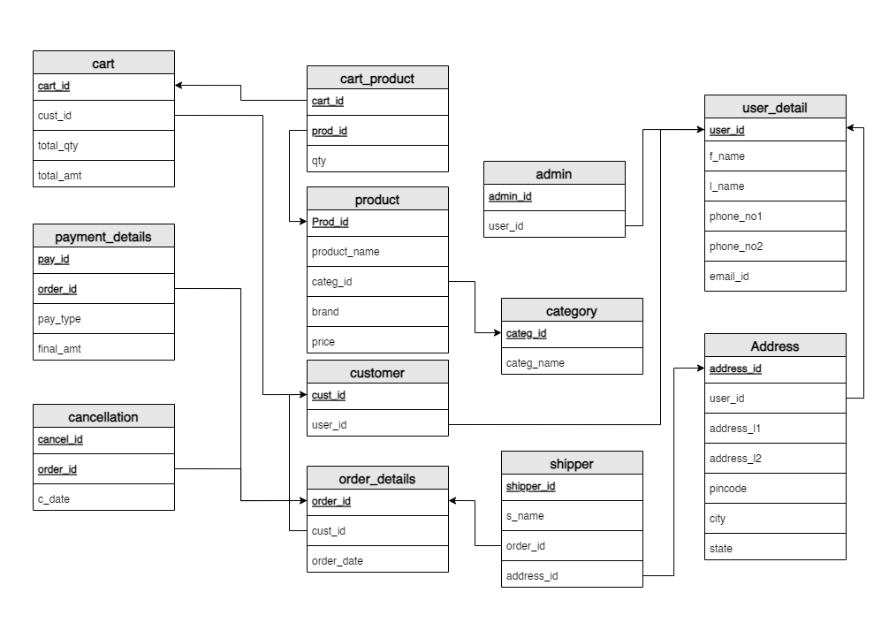

### **D. Functions**

1. **Function to filter products based on category and cost**

| create or replace function product_filter(costitem int, category varchar(20))  returns table (prod_id integer,product_name varchar(30),price decimal(10,2))  as $$  begin  return query  select pr.prod_id,pr.product_name,pr.price from product pr,category ca where pr.price<=costitem and ca.categ_name = category and pr.categ_id=ca.categ_id;  end  $$  language plpgsql;  select product_filter(14000, 'Books'); |
| --- |

**Output:**

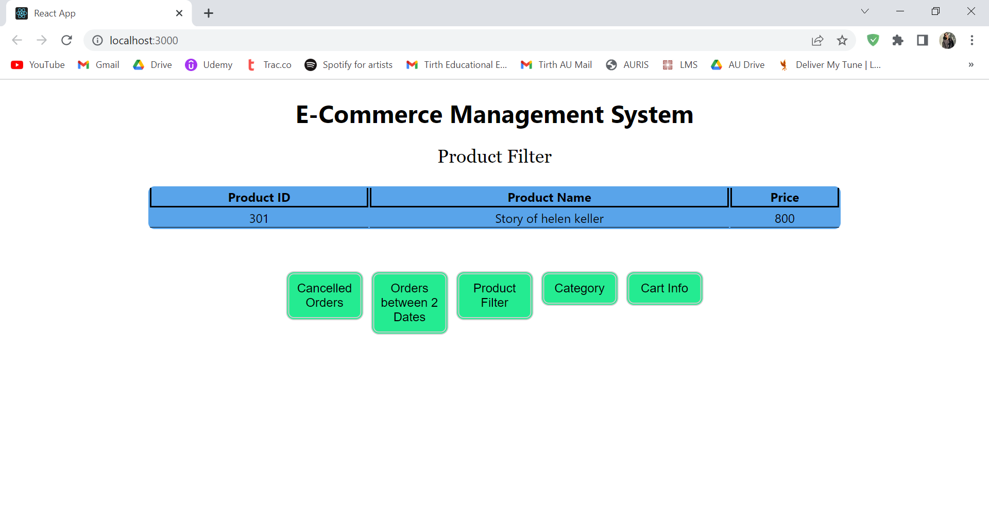

1. **Function to display the details of orders that have been canceled**

| create or replace function cancelled_orders()  returns table(order_id int,cust_id int,order_date date,cancel_id int,c_dt date)  as $$  begin  return query  select od.order_id,od.cust_id,od.order_date,cd.cancel_id,cd.c_date from order_details od,cancellation cd where od.order_id=cd.order_id;  end  $$  language plpgsql;  select cancelled_orders(); |
| --- |

**Output:**

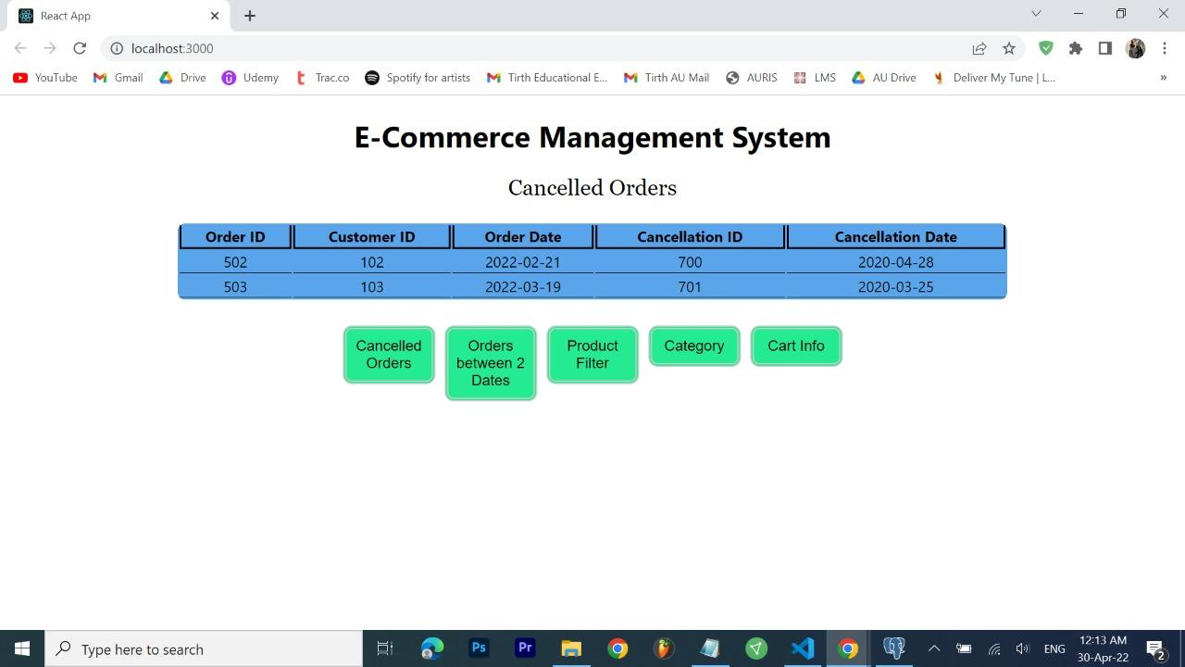

1. **Function to display the details of order that have been placed between two inputted dates.**

| create or replace function orders(date1 date,date2 date)  returns table(order_id int,cust_id int)  as $$  begin  return query  select od.order_id,od.cust_id from order_details od where order_date>=date1 and order_date<=date2;  end  $$  language plpgsql;  select orders('2022-03-15','2022-03-27'); |
| --- |

**Output:**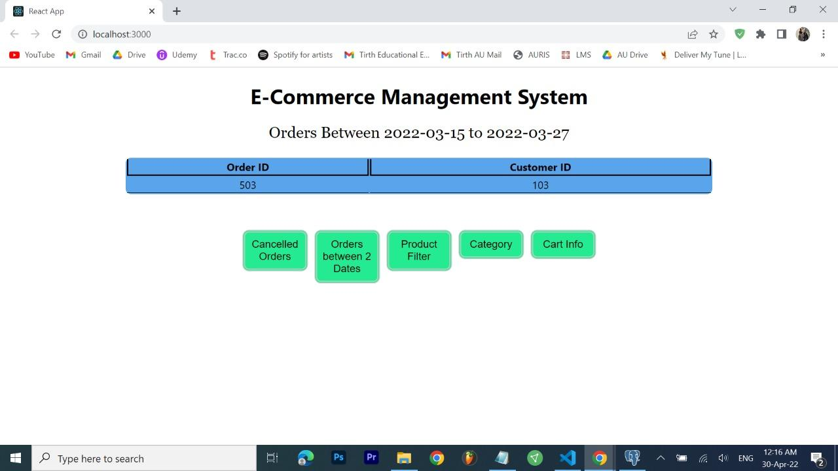

1. **Function to display the number of products of each category**

| create or replace function products()  returns table(categ_name varchar(20),product_num bigint)  as $$  begin  return query  select category.categ_name,count(prod_id) from category,product group by category.categ_name;  end  $$  language plpgsql;  select products(); |
| --- |

**Output:**

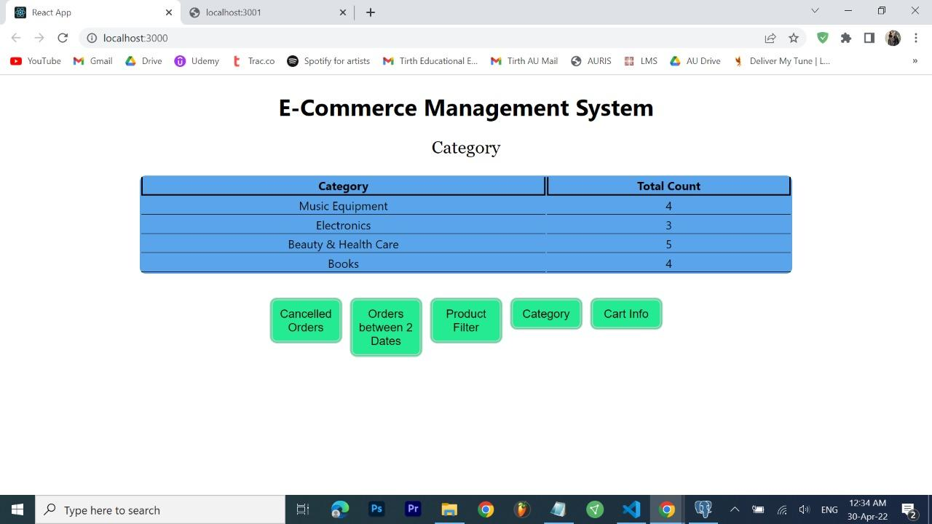

1. **Function to display the cart details of a particular customer based on the given customer id.**

| create or replace function cart_info(custid int)  returns table(cust_id int,cart_id int,total_qty decimal(3,0),total_amt decimal(11,2))  as $$  begin return query  select cart.cust_id,cart.cart_id,cart.total_qty,cart.total_amt from cart where cart.cust_id=custid;  end  $$  language plpgsql;  select cart_info(100); |
| --- |

**Output:**

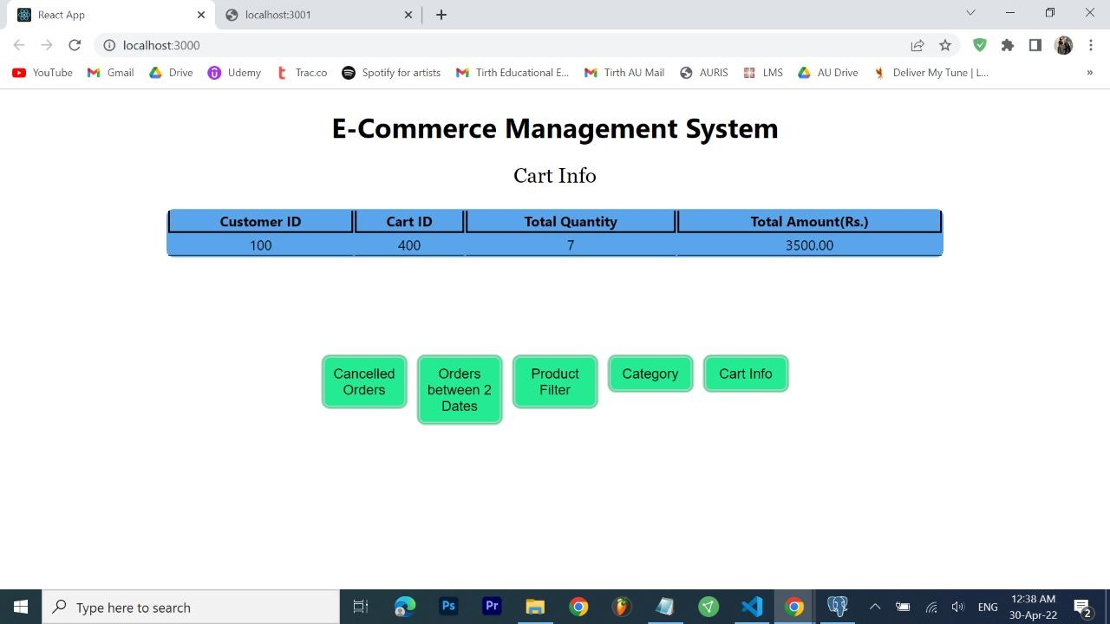

### **E. Procedures**

1. **Procedure to display the details of a customer based on an inputted customer id.**

| create or replace procedure customer_details(custid int)  language plpgsql  as $$  declare  customer1 record;  begin  select customer.cust_id,user_details.f_name,user_details.l_name,user_details.phone_no1,user_details.email_id into customer1 from customer, user_details where customer.user_id=user_details.user_id and customer.cust_id=custid;  raise exception 'Customer Id : %,First Name : %, Last Name : %, Contact Number : %, Email : %',customer1.cust_id,customer1.f_name,customer1.l_name,customer1.phone_no1,customer1.email_id;  end  $$  call customer_details(100); |
| --- |

**Output:**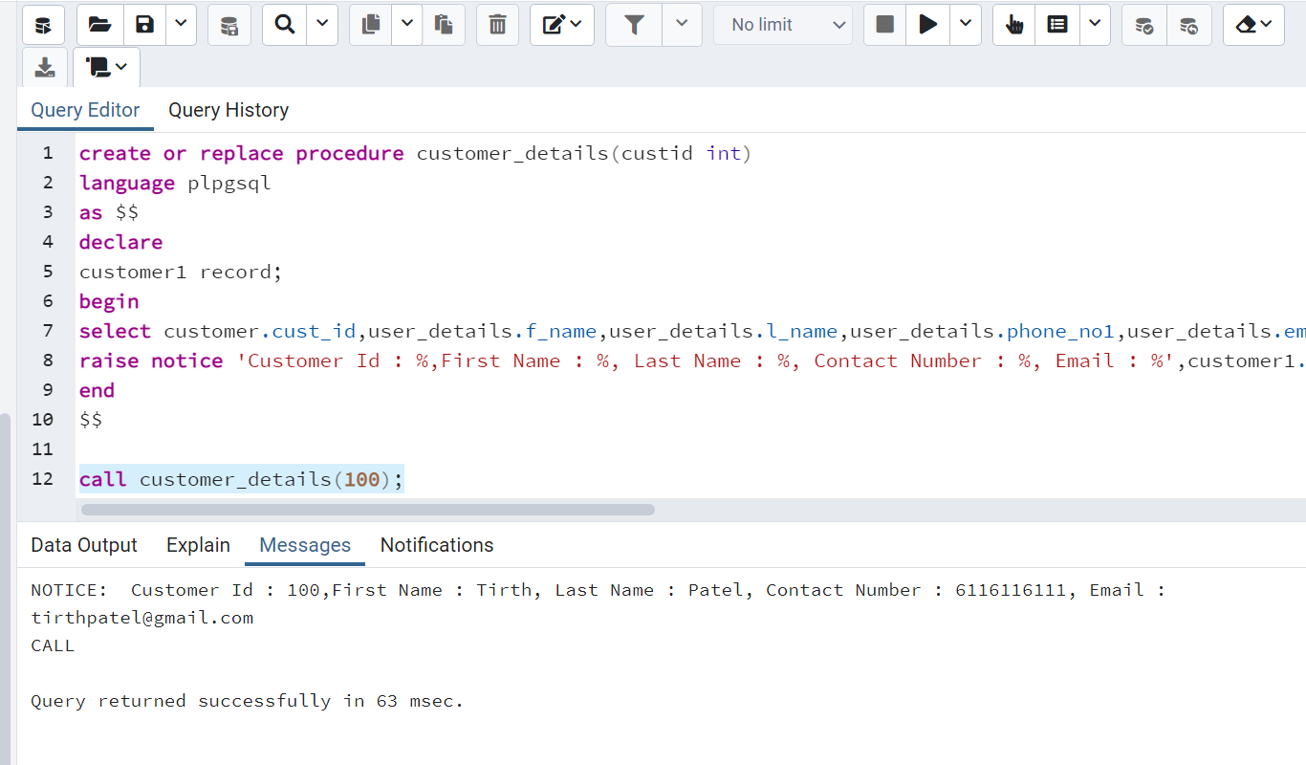

1. **Procedure to update the details (phone number or email of a customer)**

| create or replace procedure update_details1(userid int,phone1 bigint,phone2 bigint,email varchar(20))  as $$  begin  update user_details set phone_no1=phone1,phone_no2=phone2,email_id=email where user_id=userid;  end  $$  language plpgsql;  call update_details1(745, 7652327809, 8965382054, 'rushalitopper@gmail.com'); |
| --- |

**Output:**

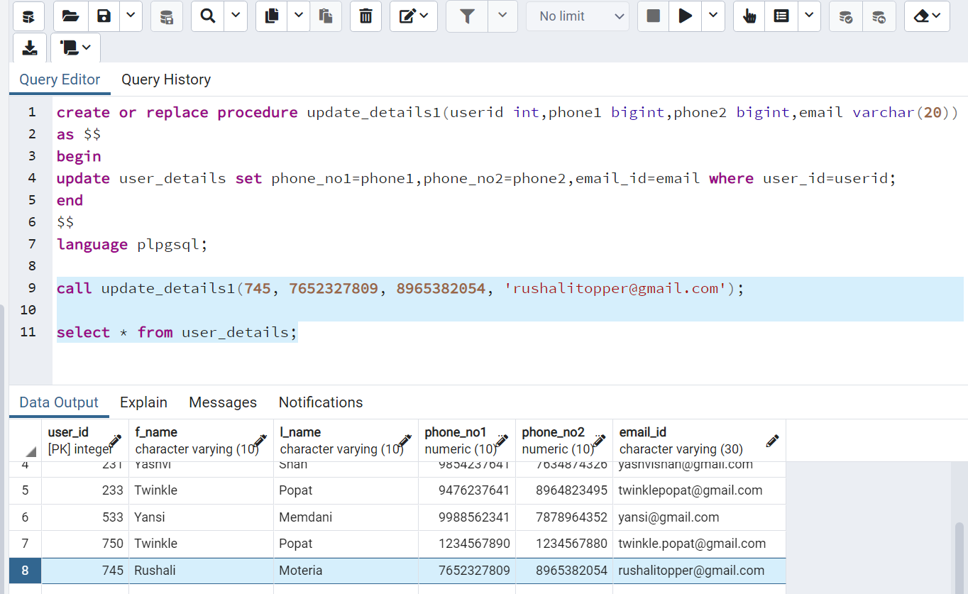

1. **Procedure to display the order history of a particular customer.**

| create or replace procedure order_history(custid1 int)  language plpgsql  as $$  declare  order1 record;  begin  for order1 in (select od.order_id,od.cust_id,od.order_date from order_details od where od.cust_id=custid1)  loop  raise exception 'Customer Id: %,Order Id : %,Order date : %',order1.cust_id,order1.order_id,order1.order_date;  end loop;  end  $$  call order_history(102); |
| --- |

**Output:**

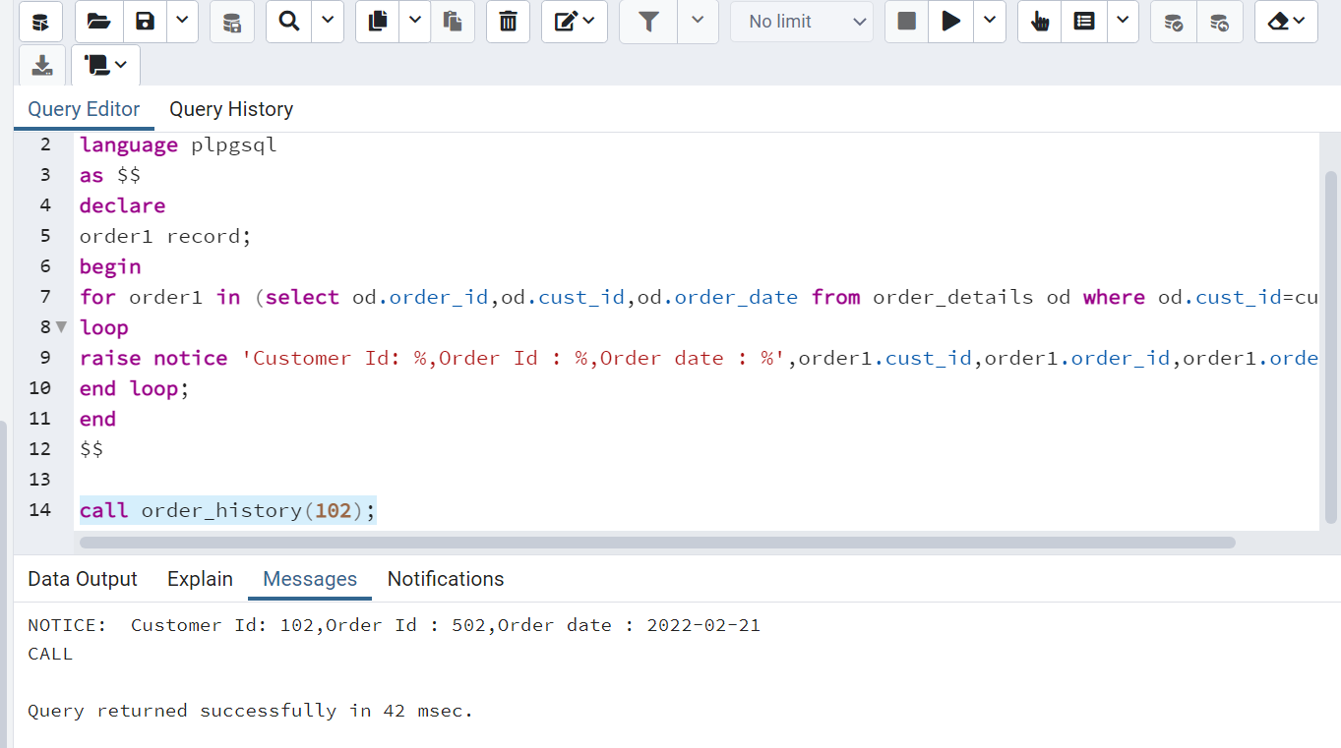

1. **Procedure to display the number of products of a particular brand.**

| create or replace procedure popular_brand()  language plpgsql  as $$  declare  rec1 record;  begin  for rec1 in (select product.brand,count(product.prod_id) as "products" from product group by product.brand)  loop  raise exception 'Brand Name: %,Products: %',rec1.brand,rec1.products;  end loop;  end  $$  call popular_brand(); |
| --- |

**Output:**

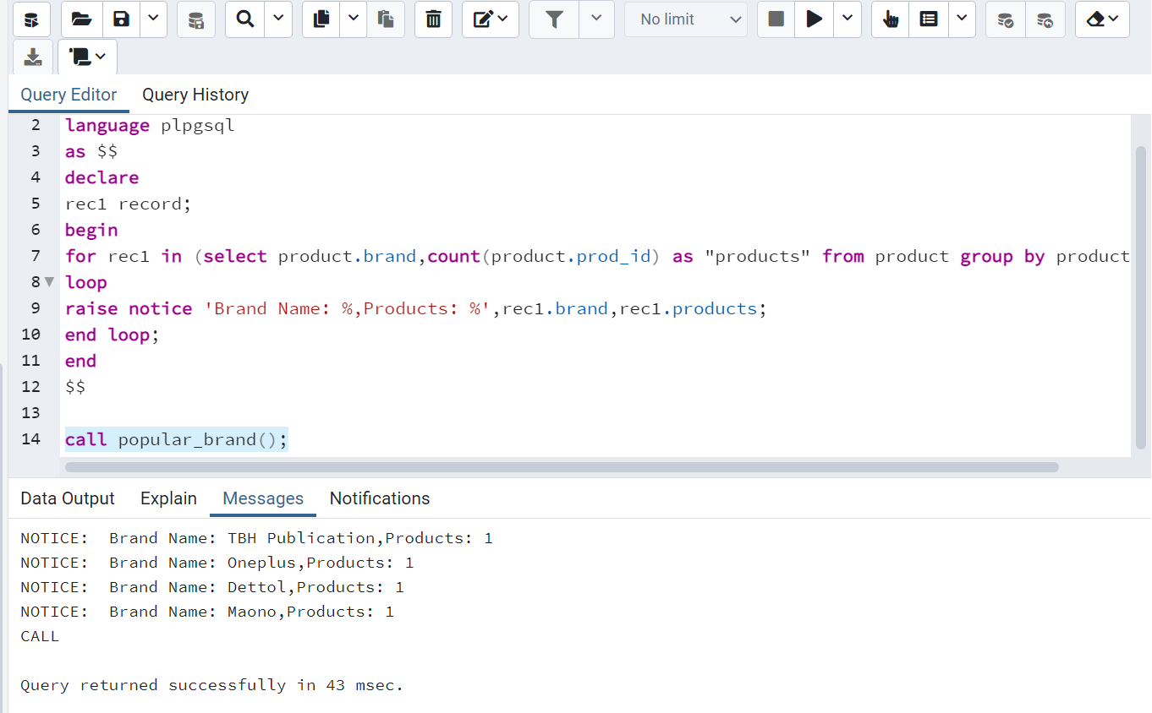

1. **Procedure to display the details of shippers.**

| create or replace procedure shipper_details(shipid int)  language plpgsql  as $$  declare  rec1 record;  begin  select shipper.shipper_id,shipper.s_name,shipper.address_id,shipper.order_id into rec1 from shipper where shipper.shipper_id=shipid;  raise exception 'Shipper Id: %,Shipper Name: %,Order Id: %,Address Id:%',rec1.shipper_id,rec1.s_name,rec1.order_id,rec1.address_id;  end  $$  call shipper_details(800); |
| --- |

**Output:**

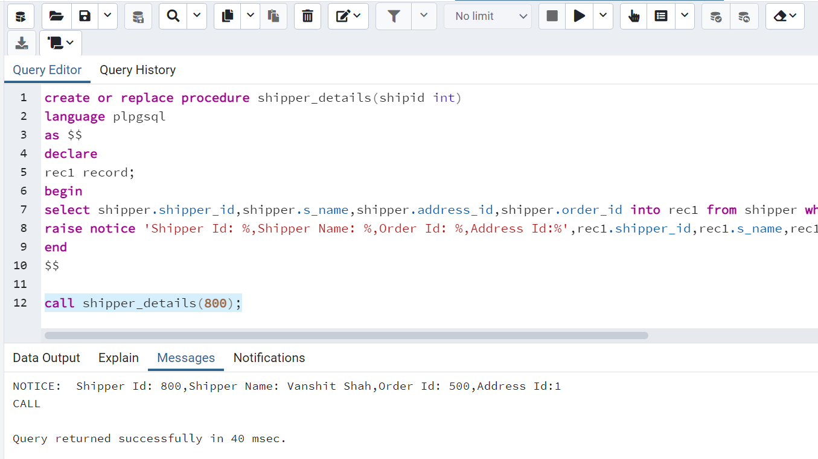

### **F. Triggers**

1. **Trigger to validate the quantity of the product. Quantity cannot be zero or negative.**

| create or replace function check_qnty() returns trigger as  $$  begin  if new.qty < 1 then  raise exception 'Quantity can not be zero or negative';  end if;  return new;  end;  $$  language plpgsql;  CREATE TRIGGER check_cartproduct BEFORE INSERT OR UPDATE ON cart_products  FOR EACH ROW EXECUTE FUNCTION check_qty;  insert into cart_product values(400, 303, 0); |
| --- |

**Output:**

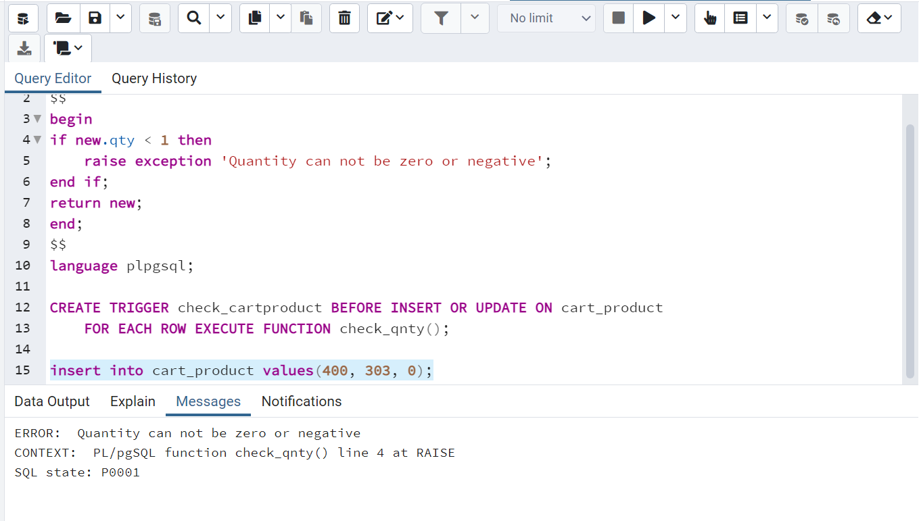

1. **Trigger to validate the inserted phone number.**

| create or replace function check_number() returns trigger as  $$  begin  if length(cast(new.phone_no1 as varchar))!=10 or length(cast(new.phone_no2 as varchar))!=10 then  raise exception 'Invalid contact number';  end if;  return new;  end;  $$  language plpgsql;  CREATE TRIGGER check_number1 BEFORE INSERT OR UPDATE ON user_details  FOR EACH ROW EXECUTE FUNCTION check_number();    insert into user_details values(913, 'Emiway', 'Bantai', '873497234', '984298732', 'emiway@gmail.com'); |
| --- |

**Output:**

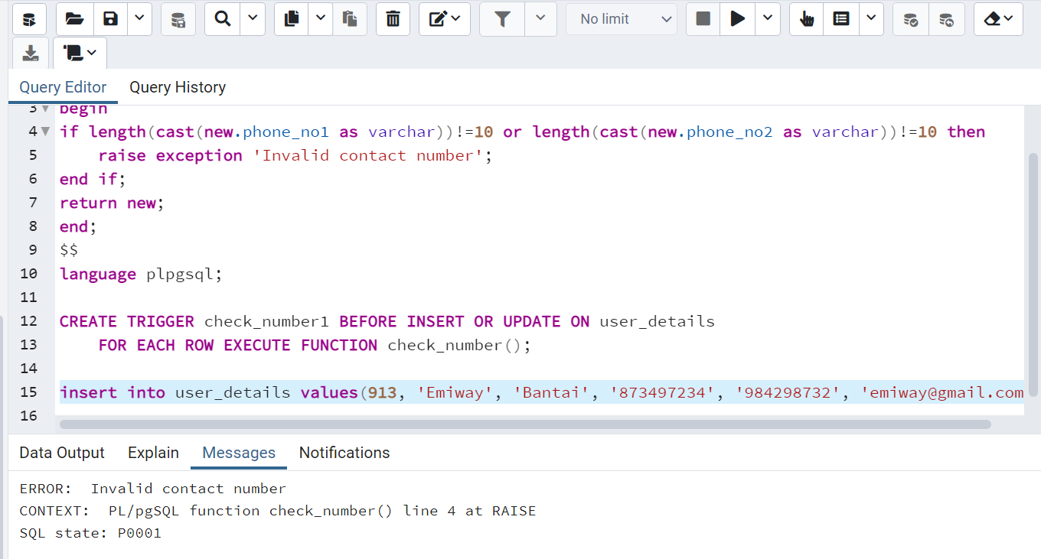

1. **Trigger to check whether the email id of the customer already exists or not. (A customer can not create multiple accounts using the same email id)**

| create or replace function() email_check returns trigger as  $$  begin  if new.user_id in (select user_details.user_id from user_details) then  raise expection 'email id already exists';  end if;  retrun new;  end;  $$  language plpgsql;  CREATE TRIGGER email_check_id BEFORE INSERT ON user_details  FOR EACH ROW EXECUTE FUNCTION check_email_id();    insert into user_details values(888, 'Paresh', 'Patel', '6414116111', '6096292051', 'tirthpatel@gmail.com'); |
| --- |

**Output:**

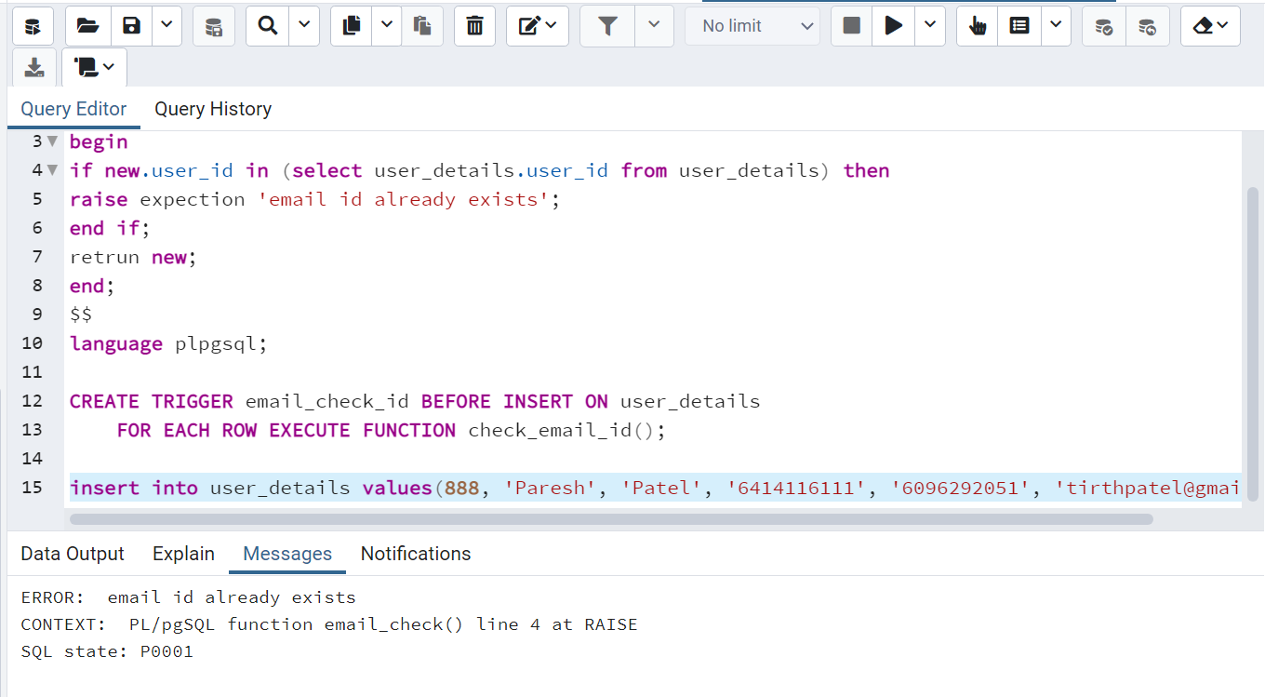

1. **Trigger to allot a cart to a customer whenever records are inserted into the customer table. We assign a cart id to the customer using a random function.**

| create or replace function generate_cart1() returns trigger as  $$  declare  cartid int;  total_amt int;  total_qty int;  custid1 int;  begin  cartid = random()*(1500-1100)+1100;  total_amt = 0;  total_qty = 0;  custid1 = new.cust_id;  insert into cart values(cartid,custid1,total_qty,total_amt);  return new;  end;  $$  language plpgsql;  CREATE TRIGGER cart_generate4 AFTER INSERT ON customer  FOR EACH ROW EXECUTE FUNCTION generate_cart1();    insert into user_details values(750,'Twinkle', 'Popat', '1234567890', '1234567880', 'twinkle.popat@gmail.com');  insert into customer values(111,750);  select * from cart; |
| --- |

**Output**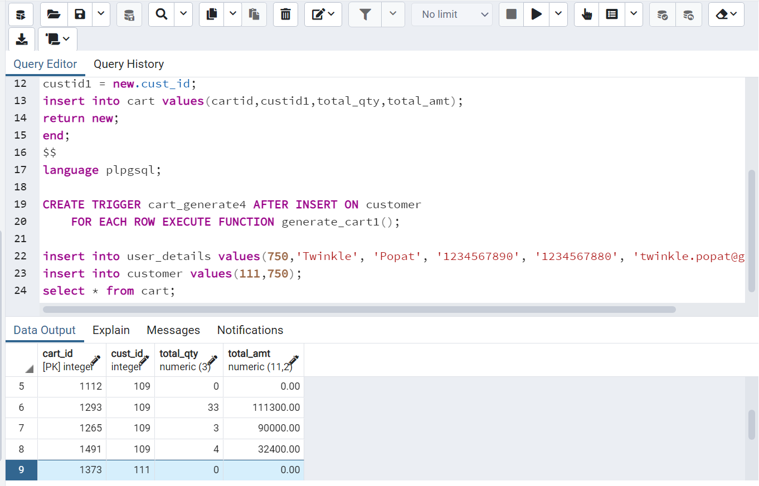

1. **Trigger to update the values in the cart table whenever a product is added to cart product table.**

| create or replace function insert_cart() returns trigger as  $$  declare  prod_price decimal(10,2);  prod_qnty int;  cart_qnty int;  amt decimal(10,2);  begin  select product.price into prod_price from product where product.prod_id=new.prod_id;  select cart.total_amt into amt from cart where cart.cart_id=new.cart_id;  prod_qnty=new.qty;  amt=amt+(prod_price*prod_qnty);  select cart.total_qty into cart_qnty from cart where cart.cart_id=new.cart_id;  cart_qnty=cart_qnty+prod_qnty;  update cart set total_qty=cart_qnty where cart.cart_id=new.cart_id;  update cart set total_amt=amt where cart.cart_id=new.cart_id;  return new;  end;  $$  language plpgsql;  CREATE TRIGGER cart_insert3 BEFORE INSERT ON cart_product  FOR EACH ROW EXECUTE FUNCTION insert_cart();  insert into cart_product values(1373, 301, 7);  select * from cart; |
| --- |

**Output:**